Assignment 02 – L1F23BSSE0388 – P4  
My personal portfolio website

Code With Output Screen shots:

Home page:

<!DOCTYPE html>

<html lang="en">

<head>

    <meta charset="UTF-8">

    <meta name="viewport" content="width=device-width, initial-scale=1.0">

  <link rel="stylesheet" href="https://cdnjs.cloudflare.com/ajax/libs/font-awesome/6.5.0/css/all.min.css">

  <link rel="stylesheet" href="style.css">

    <title>Portfolio Home page</title>

</head>

<body>

    <header>

        <a href="#" class="logo">Ansir</a>

        <nav>

            <div class="nav">

                <a href="A_home.html">Home</a>

                <a href="A_About.html">Skills</a>

                <a href="A_contact.html">Contact</a>

            </div>

        </nav>

    </header>

    <section class="Home">

        <div class="Home-img"><img src="Ansir.jpg" alt=""></div>

        <div class="Home_contact">

        <h1>Hi it's <span>Ansir</span></h1>

            <h3 class="typing-text"><span></span></h3>

            <p>I am a Software Engineering student and a skilled web developer.

                I have 2 years of experience in web development.

                I am continuously enhancing my skills in programming and modern technologies.

                </p>

        </div>

        <div>

        <img style="height: 170px;" src="back.jpg" alt="">

        <img src="computer.jpg" alt="">

    </div>

        <br>

            <div class="social_icons">

                <a href="#"><i class="fa-brands fa-linkedin"></i></a>

                <a href="#"><i class="fa-brands fa-github"></i></a>

                <a href="#"><i class="fa-brands fa-twitter"></i></a>

                <a href="#"><i class="fa-brands fa-instagram"></i></a>

                <a href="#"><i class="fa-brands fa-youtube"></i></a>

                <a href="#"class="Hire-me">Hire-me</a>

            </div>

    </section>

</body>

</html>

**Output:**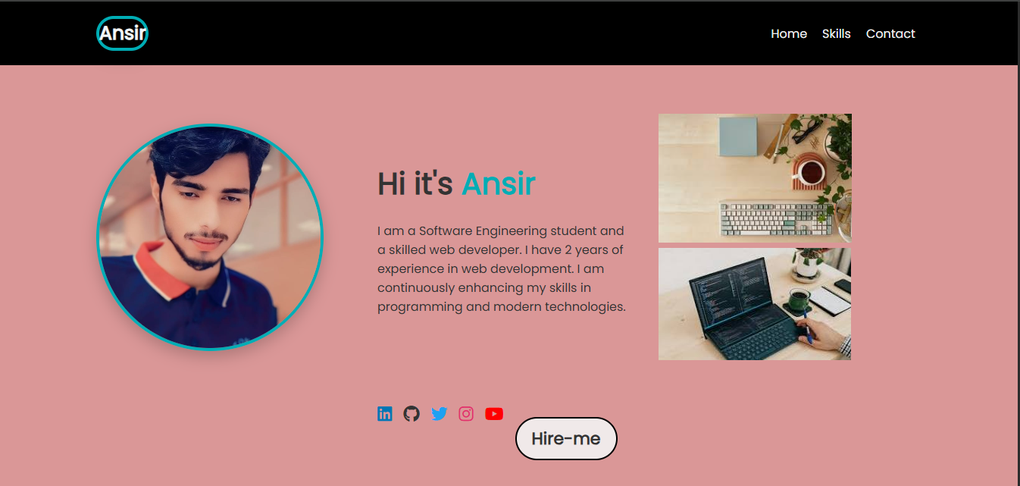

**Skills page:**

<!DOCTYPE html>

<html lang="en">

<head>

  <meta charset="UTF-8">

  <meta name="viewport" content="width=device-width, initial-scale=1">

  <title>About Me - Ansir</title>

  <link rel="stylesheet" href="https://cdnjs.cloudflare.com/ajax/libs/font-awesome/6.5.0/css/all.min.css">

  <link rel="stylesheet" href="style.css">

</head>

<body>

    <body>

        <header>

            <a href="#" class="logo">Ansir</a>

            <nav>

                <div class="nav">

                    <a href="A_home.html">Home</a>

                    <a href="A_About.html">Skills</a>

                    <a href="A_contact.html">Contact</a>

                </div>

            </nav>

        </header>

  <section class="about-section">

    <h1>About <span>Me</span></h1>

    <div class="about-container">

      <div class="about-image">

        <img src="Ansir.jpg" alt="Ansir">

      </div>

      <div class="about-text">

        <p>Hello! I am <strong>Ansir</strong>, a dedicated Software Engineering student with a strong passion for web development. With 2 years of practical experience, I specialize in creating modern, responsive websites using HTML, CSS, JavaScript, and various frameworks. I am constantly learning and evolving to keep up with the latest tech trends.</p>

        <h3>Education</h3>

        <ul>

          <li><strong>BS Software Engineering</strong>  UCP (2023 - Start and 2025 - present)</li>

          <li><strong>ICS</strong>  BISE Sahiwal, 916/1100</li>

          <li><strong>Matric</strong>  GHS Depalpur, 1080/1100</li>

        </ul>

        <h3>Skills</h3>

        <div class="skills-list">

          <span>HTML</span>

          <span>CSS</span>

          <span>JavaScript</span>

          <span>React (Basics)</span>

          <span>Java / C++</span>

          <span>Responsive Designer</span>

        </div>

      </div>

    </div>

  </section>

</body>

</html>

**Output:**

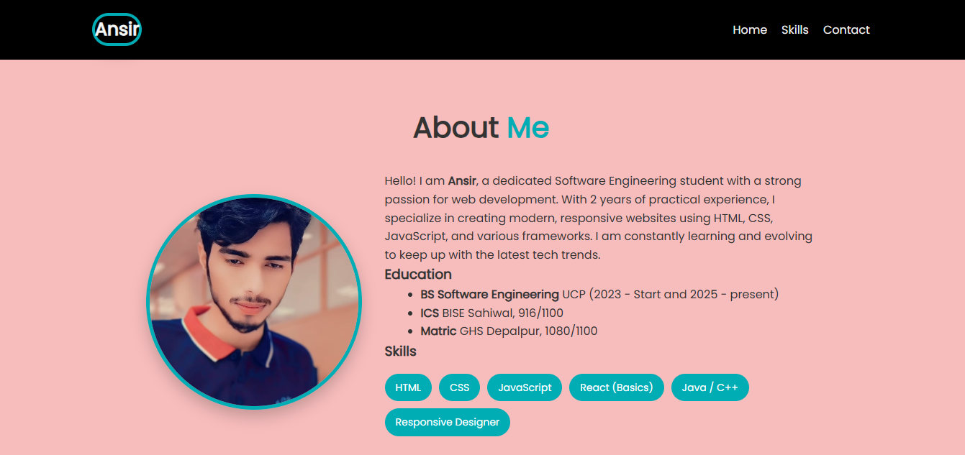

**Contact page:**

<!DOCTYPE html>

<html lang="en">

<head>

  <meta charset="UTF-8">

  <meta name="viewport" content="width=device-width, initial-scale=1">

  <title>Contact - Ansir</title>

  <link rel="stylesheet" href="https://cdnjs.cloudflare.com/ajax/libs/font-awesome/6.5.0/css/all.min.css">

  <link rel="stylesheet" href="style.css">

</head>

  <header>

    <a href="#" class="logo">Ansir</a>

    <nav>

      <div class="nav">

        <a href="A_home.html">Home</a>

        <a href="A_About.html">Skills</a>

        <a href="A_contact.html" class="active">Contact</a>

      </div>

    </nav>

  </header>

  <section class="contact-section">

    <h1>Contact <span>Me</span></h1>

    <div class="contact-container">

      <div class="contact-info">

        <p><i class="fas fa-envelope"></i> Email: ansir1869@gmail.com</p>

        <p><i class="fas fa-phone"></i> Phone: 0345-0570563</p>

        <p><i class="fas fa-map-marker-alt"></i> Location: Depalpur, Pakistan</p>

        <div class="social_icons">

          <a href="#"><i class="fa-brands fa-linkedin"></i></a>

          <a href="#"><i class="fa-brands fa-github"></i></a>

          <a href="#"><i class="fa-brands fa-twitter"></i></a>

          <a href="#"><i class="fa-brands fa-instagram"></i></a>

        </div>

      </div>

      <form class="contact-form" action="#" method="post">

        <input type="text" placeholder="Your Name" required>

        <input type="email" placeholder="Your Email" required>

        <textarea rows="5" placeholder="Your Message" required></textarea>

        <button type="submit">Send Message</button>

      </form>

    </div>

  </section>

  <footer>

    <p>© 2025 Ansir | All rights reserved.</p>

    <div class="footer-links">

      <a href="#"><i class="fa-brands fa-linkedin"></i></a>

      <a href="#"><i class="fa-brands fa-github"></i></a>

      <a href="#"><i class="fa-brands fa-twitter"></i></a>

    </div>

  </footer>

</body>

</html>

**Output:**

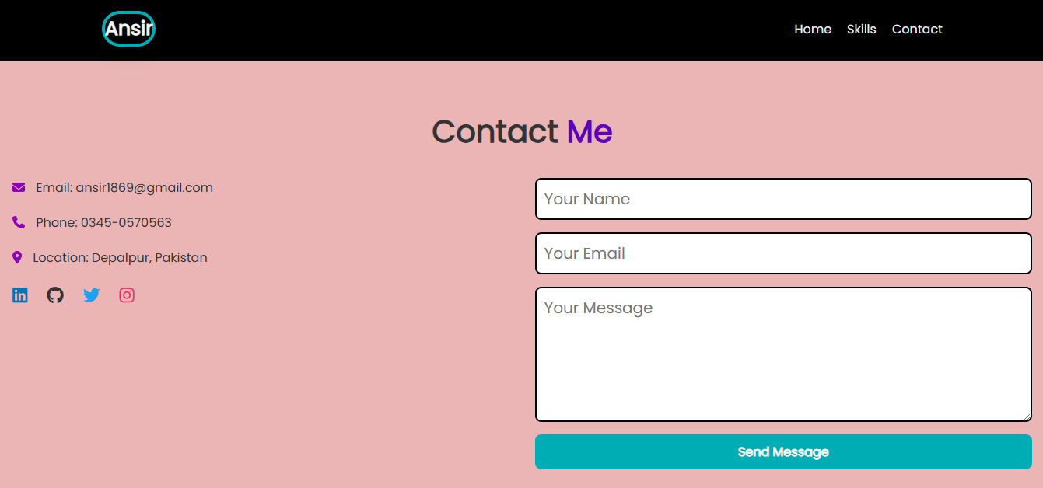

**All CSS code:**

@import url('https://fonts.googleapis.com/css2?family=Poppins&display=swap');

* {

    margin: 0;

    padding: 0;

    box-sizing: border-box;

    font-family: 'Poppins', sans-serif;

}

body {

    background: #d3bdbd;

    color: #333;

}

header {

    display: flex;

    justify-content: space-between;

    align-items: center;

    padding: 1.2rem 10%;

    background: black;

    color: white;

    position: sticky;

    top: 0;

    z-index: 100;

}

.logo {

    font-size:25px;

    font-weight: bold;

    color: #f3f6f7;

    text-decoration: none;

    object-fit: cover;

    box-shadow: 0 8px 20px rgba(0, 0, 0, 0.2);

    border: 4px solid #00adb5;

    border-radius: 60px;

    animation: rotateImage 6s linear infinite;

}

.logo:hover {

    color: #00adb5;

    transform: scale(1.2);

}

.nav {

    display: flex;

    flex-wrap: wrap;

}

.nav a {

    margin-left: 20px;

    text-decoration: none;

    color: #eee;

    font-weight: 500;

    transition: color 0.3s ease;

}

.nav a:hover {

    color: #00adb5;

}

.Home {

    display: grid;

    grid-template-columns: repeat(auto-fit, minmax(300px, 1fr));

    gap: 2rem;

    align-items: center;

    padding: 4rem 10%;

    background: #da9797;

    animation: fadeInUp 1s ease-in-out;

}

.Home-img img {

    width: 300px;

    height: 300px;

    border-radius: 80%;

    object-fit: cover;

    box-shadow: 0 8px 20px rgba(0, 0, 0, 0.2);

    border: 4px solid #00adb5;

    animation: rotateImage 6s linear infinite;

}

.Home_contact {

    display: flex;

    flex-direction: column;

    justify-content: center;

}

.Home h1 {

    font-size: 2.5rem;

    margin-top: 1rem;

}

.Home h1 span {

    color: #00adb5;

}

.typing-text {

    font-size: 1.5rem;

    color: #555;

}

.Home p {

    margin: 20px 0;

    max-width: 600px;

}

.social_icons {

    display: flex;

    gap: 15px;

    margin: 16px 0;

}

.social_icons a {

    font-size:22px;

    color: #333;

    transition: transform 0.3s ease, color 0.3s ease;

}

.social_icons a .fa-linkedin { color: #0077b5; }

.social_icons a .fa-github { color: #333; }

.social_icons a .fa-twitter { color: #1da1f2; }

.social_icons a .fa-instagram { color: #e1306c; }

.social_icons a .fa-youtube { color: #ff0000; }

.social_icons a:hover {

    color: #00adb5;

    transform: scale(1.2);

}

.Hire-me {

    display: inline-block;

    background-color: #f0e9e9;

    border: 2px solid black;

    color: white;

    padding: 10px 20px;

    margin-top: 20px;

    border-radius: 30px;

    font-weight: bold;

    text-decoration: none;

}

.Hire-me:hover {

    background: #8f9100;

}

@keyframes fadeInUp {

    from {

        opacity: 0;

        transform: translateY(40px);

    }

    to {

        opacity: 1;

        transform: translateY(0);

    }

}

@media (max-width: 768px) {

    .nav {

        justify-content: center;

        margin-top: 10px;

    }

    .Home {

        grid-template-columns: 1fr;

        text-align: center;

    }

}

.about-section {

    padding: 64px;

    background: #f0f0f0;

    animation: fadeInUp 1s ease-in-out;

    background-color:rgb(247, 188, 188);

}

.about-section h1 {

    text-align: center;

    font-size: 40px;

    margin-bottom: 32px;

}

.about-section h1 span {

    color: #00adb5;

}

.about-container {

    display: flex;

    flex-wrap: wrap;

    gap: 32px;

    align-items: center;

    justify-content: center;

}

.about-image img {

    width: 300px;

    height: 300px;

    border-radius: 50%;

    border: 5px solid #00adb5;

    object-fit: cover;

    box-shadow: 0 10px 20px rgba(0,0,0,0.2);

}

.about-text {

    max-width: 600px;

    font-size: 16px;

    line-height: 1.6;

}

.about-text ul {

    padding-left: 50px;

}

.skills-list {

    display: flex;

    flex-wrap: wrap;

    gap: 10px;

    margin-top: 16px;

}

.skills-list span {

    background-color: #00adb5;

    color: white;

    padding: 8px 15px;

    border-radius: 20px;

    font-size: 14px;

}

footer {

    text-align: center;

    padding: 16px;

    background: #0a0a0a;

    color: white;

}

.footer-links a {

    color: #00adb5;

    font-size: 20px;

    transition: transform 0.3s;

    gap: 10px;

}

.footer-links a:hover {

    transform: scale(1.2);

}

.contact-section {

    padding: 60px 20px;

    background: #f8f8f8;

    animation: fadeInUp 1s ease-in-out;

    background-color: rgb(235, 181, 181);

}

.contact-section h1 {

    text-align: center;

    font-size: 40px;

    margin-bottom: 30px;

}

.contact-section h1 span {

    color: #5e00b5;

}

.contact-container {

    display: flex;

    flex-wrap: wrap;

    gap: 32px;

    justify-content: center;

    align-items: flex-start;

}

.contact-info {

    flex: 1;

    min-width: 250px;

    font-size: 16px;

}

.contact-info p {

    margin-bottom:20px;

    color: #333;

}

.contact-info i {

    color: #8b00b5;

    margin-right: 10px;

}

.contact-form {

    flex: 1;

    min-width: 300px;

    display: flex;

    flex-direction: column;

    gap: 16px;

}

.contact-form input,

.contact-form textarea {

    padding: 10px;

    border: 2px solid black;

    border-radius: 8px;

    font-size: 20px;

}

.contact-form button {

    padding: 10px;

    border: none;

    background-color: #00adb5;

    color: white;

    font-size: 1rem;

    font-weight: bold;

    border-radius: 8px;

    cursor: pointer;

}

.contact-form button:hover {

    background-color: #007f84;

}

@media (max-width: 768px) {

    .contact-container {

        flex-direction: column;

        text-align: center;

    }

    .contact-info,

    .contact-form {

        width:20px ;

    }

}